Manipal University Jaipur has organised a Blood Donation Camp on 16th November, 2017 in collaboration with Jain social Group (Central), Rotary Club and HDFC bank at University campus. The event took place form morning 8:00 am till evening 6 pm.
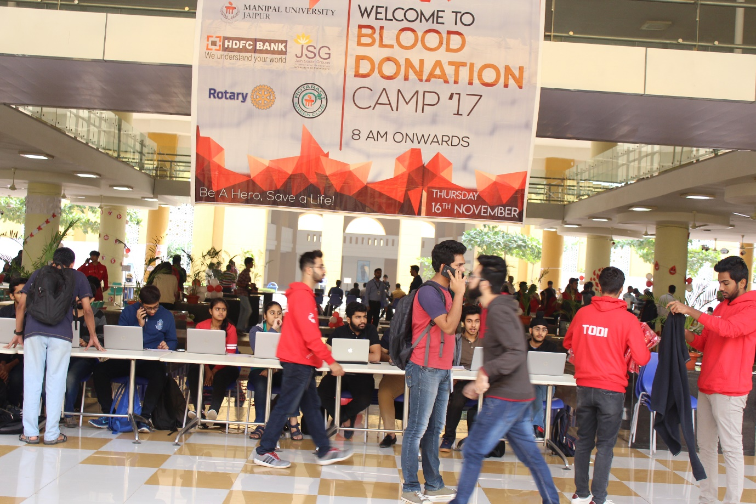
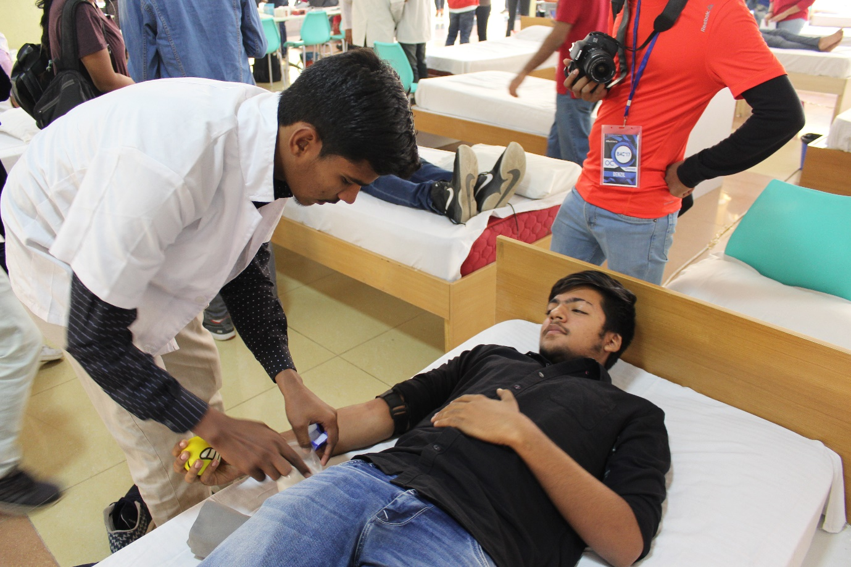

A team of 11 hospitals were present to take units of blood along with them. They were
1. Santokba Durlabhji Memorial Hospital (SDMH)
2. Swasthya Kalyan Blood Bank
3. Mahatma Gandhi Hospital, Jaipur
4. Jaipuria Hospital Blood Bank
5. Monilek Blood Bank
6. Life Care Blood Bank
7. Sawai Man Singh Hospital (SMS)
8. SMS Troma Unit
9. Bhagwan Mahaveer Cancer Hospital & Research Centre
10. Triveni Blood Bank, Ajmer
11. Zanana Hospital Jaipur
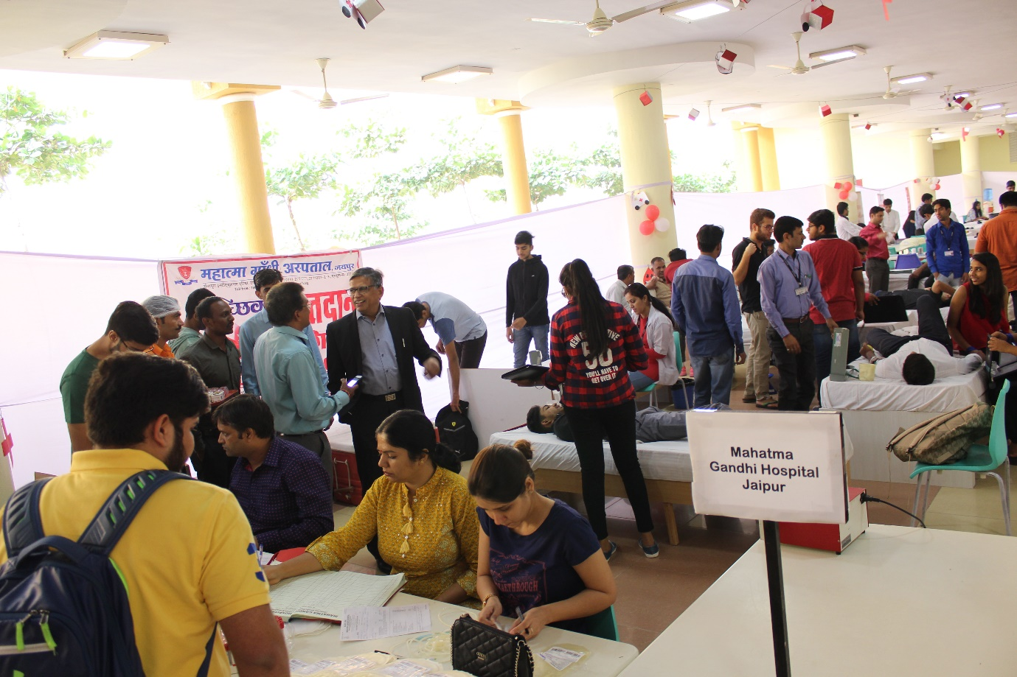
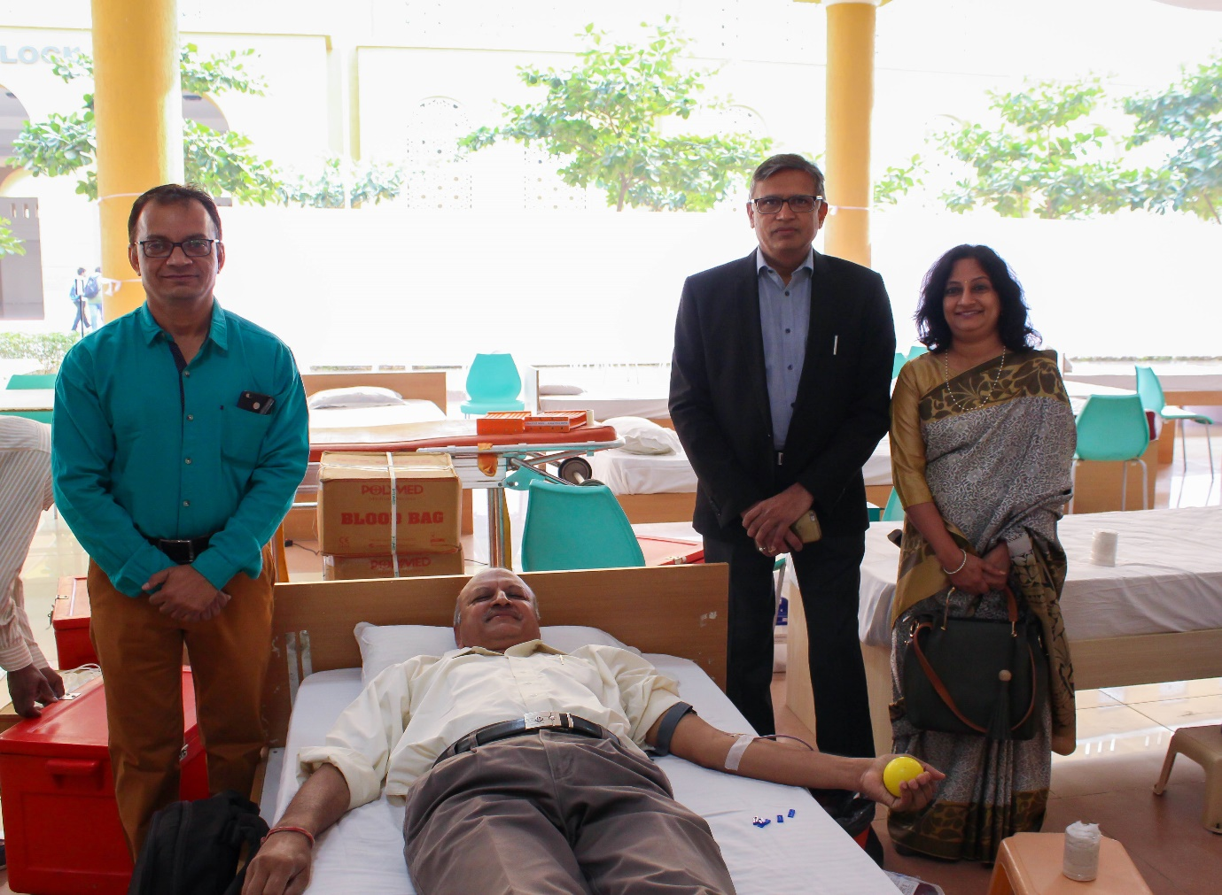

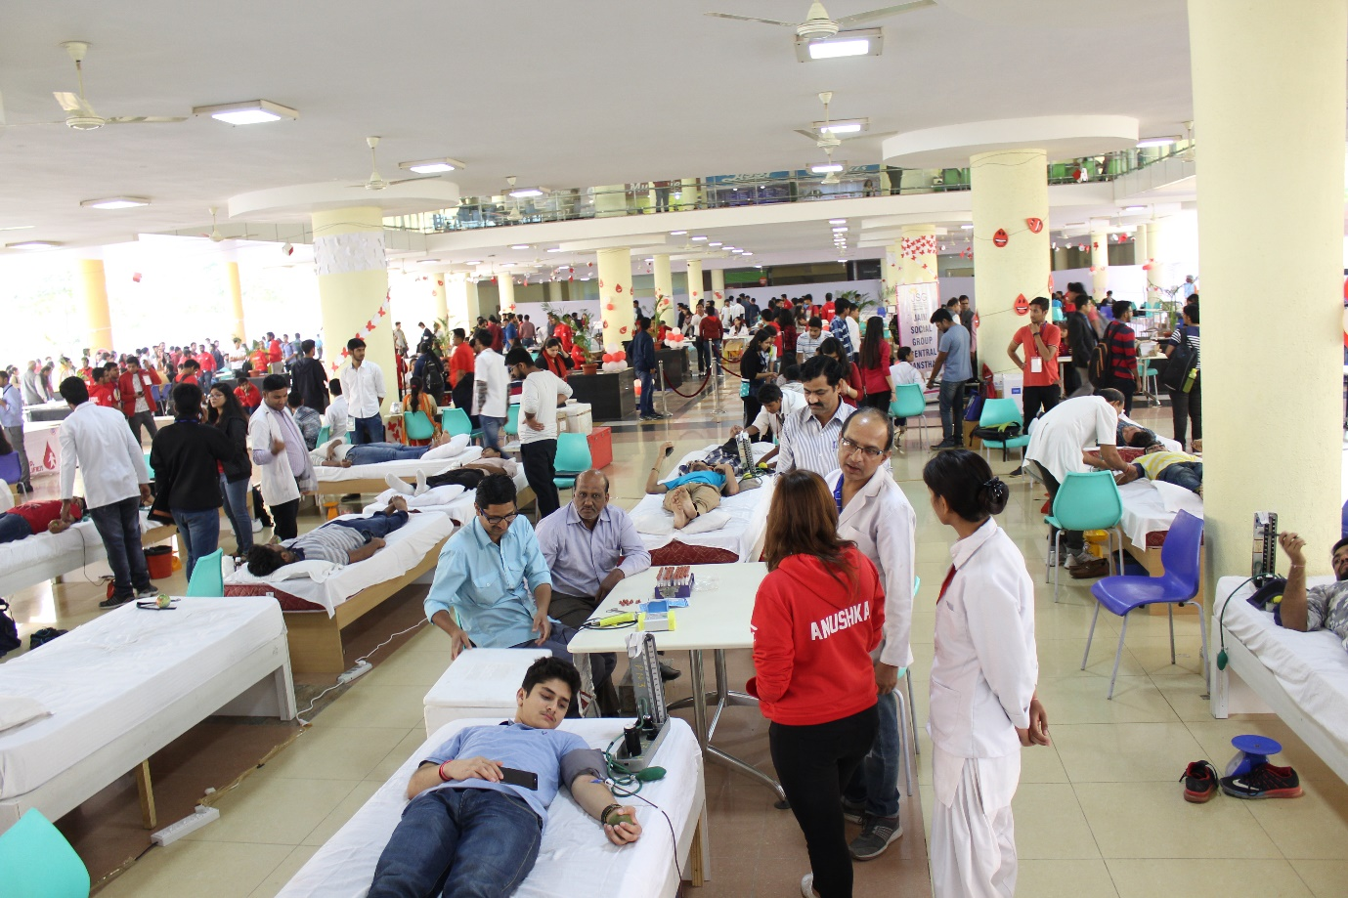
In this camp overwhelming number of Volunteers of Manipal University Jaipur has participated with vivacity. The students and employees of Manipal University Jaipur donated the blood. Total 1661 units of blood was connected. After that, different hospitals and our sponsors delivered the speech by telling audiences that the donated blood would be used for saving the lives of the injured and the sick, saying that the blood donation does not weaken the donators. The recovery takes place very soon. He talked about facts/ myths/ Blood Groups related information.
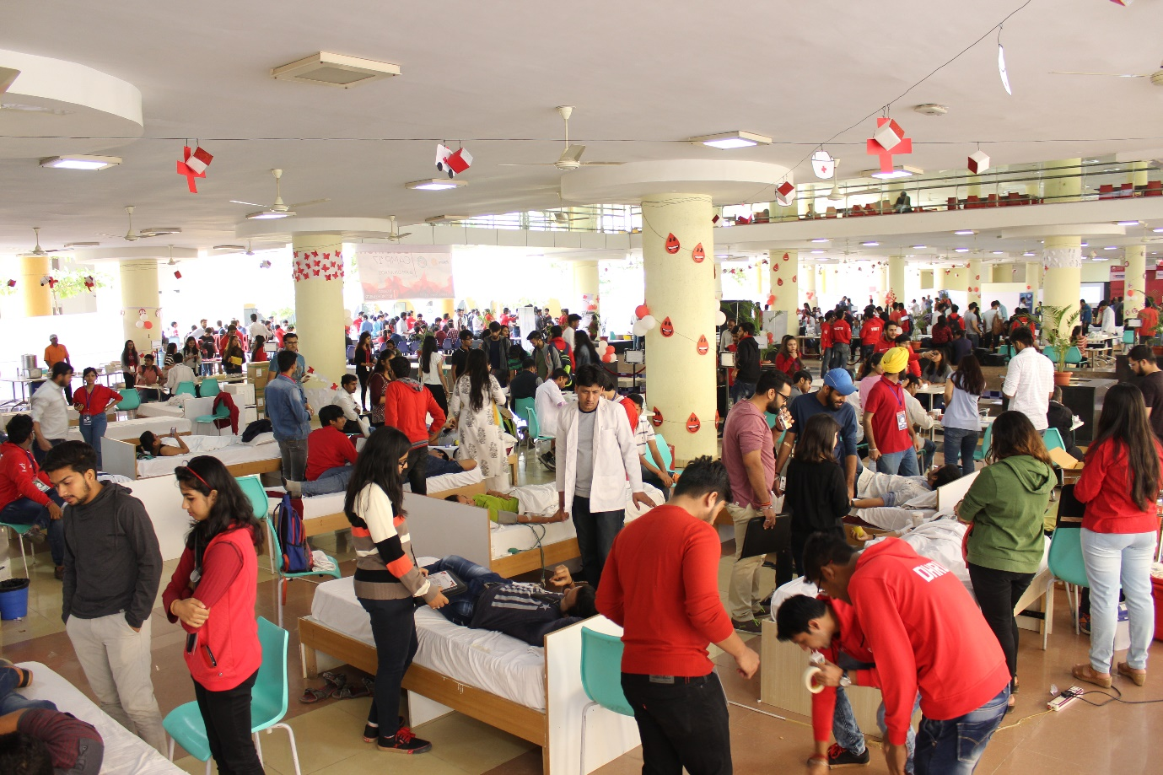
Crowd of Manipal University Jaipur was enthusiastic for donating the blood. They were laid to bed with a soft ball in the hand. Then they started process. It took nearly half an hour for one person as first their haemoglobin, blood pressure were checked, and then after it, refreshments were given. Certificates and a free kit were also given to the blood donators.
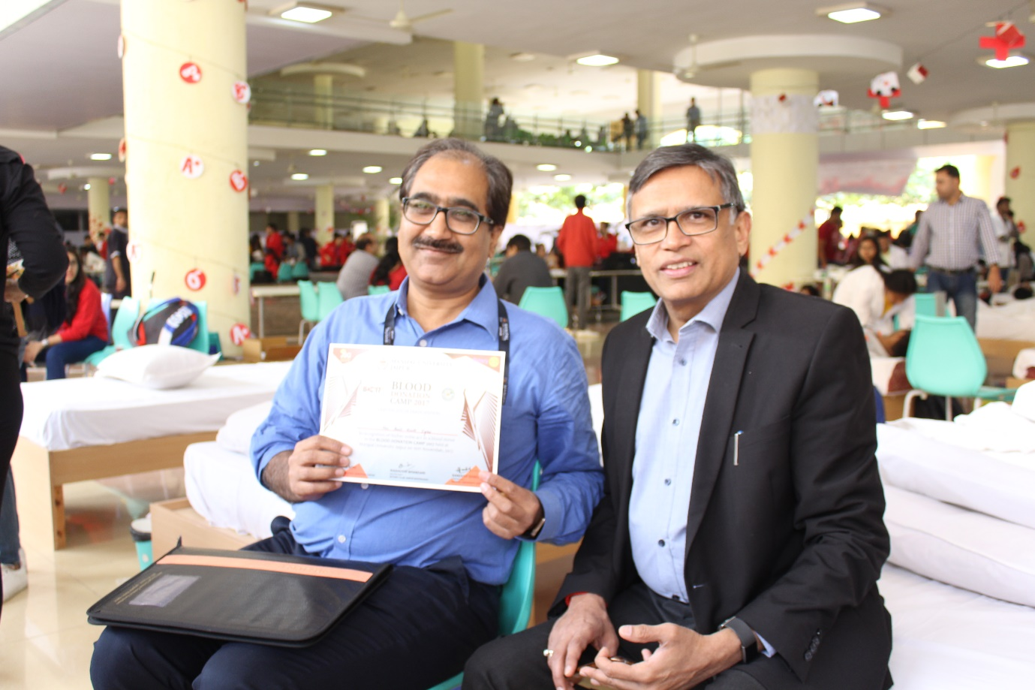
It was followed by a closing ceremony at 5.30 pm by giving the bouquet and memento by the President of Manipal University Jaipur to all the hospitals that participated in the programme. Everybody enjoyed that. It was certainly a memorable day for all of us. Every one decided to donate blood in future also.
